Name of Institution: Spanish Air Force Academy (SAFA)
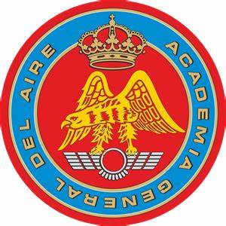
Branch of Armed Forces: Air Force (FULL)
COMMANDER
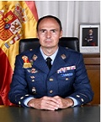
Colonel Pascual SORIA MARTINEZ
Academic Degrees: Degree in Industrial Organization Engineering, Master in Decision Support Techniques.
Academic Offer:
In accordance with Spanish law, military students at the SAFA earn their degree through an accredited and embedded civilian military institute (Centro Universitario de la Defensa or CUD) collocated on San Javier Air Base. All students who graduate from both the CUD and the Spanish Air Force Academy are awarded a degree in Industrial Organizational Engineering via a 5-year degree program.
Students who already have a degree and attend the Academy for mandatory military training, spend one to two years developing their skillsets as an officer, military professional, and learning their specialty.
Study Programmes:
- General Corps (5 years) Degree in Industrial Organization Engineering. Military specialities:
- Spanish Air Force pilots
- Aerospace Defense and Control
- Cyberspace and Cyber Defense
- Officer candidates with undergraduate degree complete
- Common Corps (1 year of military studies, 1 month in SAFA)
- Engineering Corps (1 year)
- Quartermaster Corps (2 years)
- Master in Decision Support Techniques (available for officers)

Aeronautical Training
Pilot training at the Spanish Air Force Academy is comprised of both theoretical and theoretical-practical subjects that are taught throughout students’ academic tenure.
The subject content and phases in Flight Training meet the requirements of both the Spanish Air Force and the EASA Part-FCL and EU-OPS regulations for Civil Aviation.

Flight Training is divided into three main phases/stages:

- Phase I: Screening/Elementary - 792 Squadron (3rd course)
- Phase II: Basic - 792 Squadron (4th course)
- Phase III: Advanced - Fighter School, Transport School, Helicopter School (5th course).
International Activities and Exchange Offer:
- Bilateral students exchange USAFA-SAFA (4 months long)
- Bilateral students exchange FAFA-SAFA (4 months long)
- Tri-lateral sport competition (FR-IT-SP), Frozen.
- Bilateral exchange visit PAFA-SAFA (1 week)
- Common Modules and short activities included in the EMILYO project
- Erasmus+ Teaching, Training, Traineeship activities
Number of students: 431
Location: San Javier, Murcia (South-east of Spain)
Contact information:
Address: Colonel López Peña St. Santiago de la Ribera 30720, San Javier, Murcia Spain
Phone numbers:
Tel. +34 968-189-306/ +34 968 189 286
Mail:
General Mail: poc_aga@ea.mde.es
International Relations Office: rrii_aga@mde.es
Web Page
Academic offer: Studies - University Defense Center (upct.es)/ www.ejercitodelaire.mde.es
Languages taught: Spanish, English, French (optional)
